Week 1 Lab

Student Details:
Student Name: Manjot singh
Student Id:991808820
Program: Computer Systems Technician – Information Technology Infrastructure and Services

Exercise 1
Step 1:FOR CHECKING THE CURRENT OUS on server
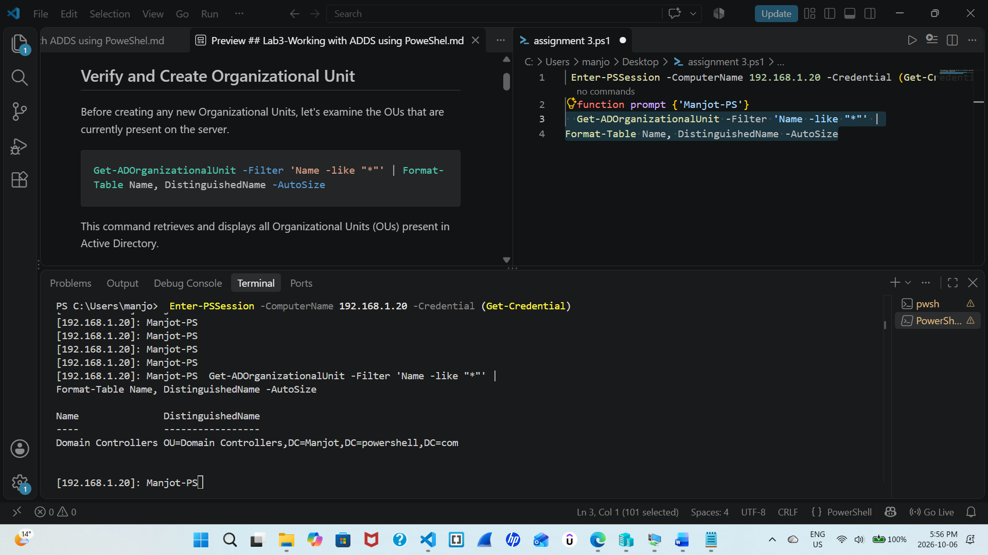
Paste the full screenshot here. Briefly explain the output.
Step 2: We are now creating a ou named IT
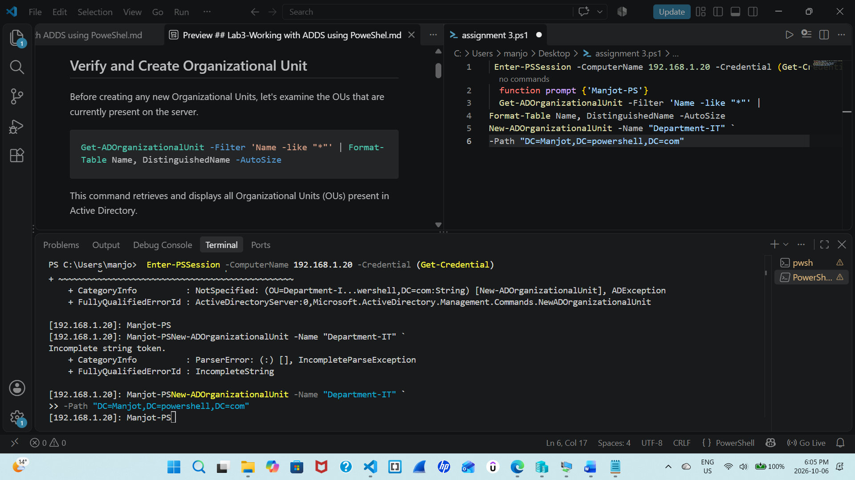
Paste the full screenshot here.
Step 3:verifying for steps
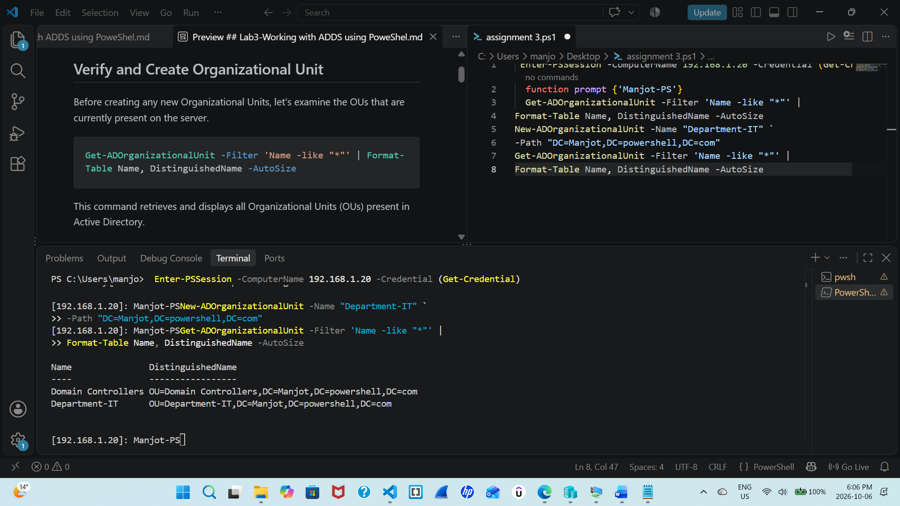
Paste the full screenshot here
Step 4:creating a test user and adding in our domain
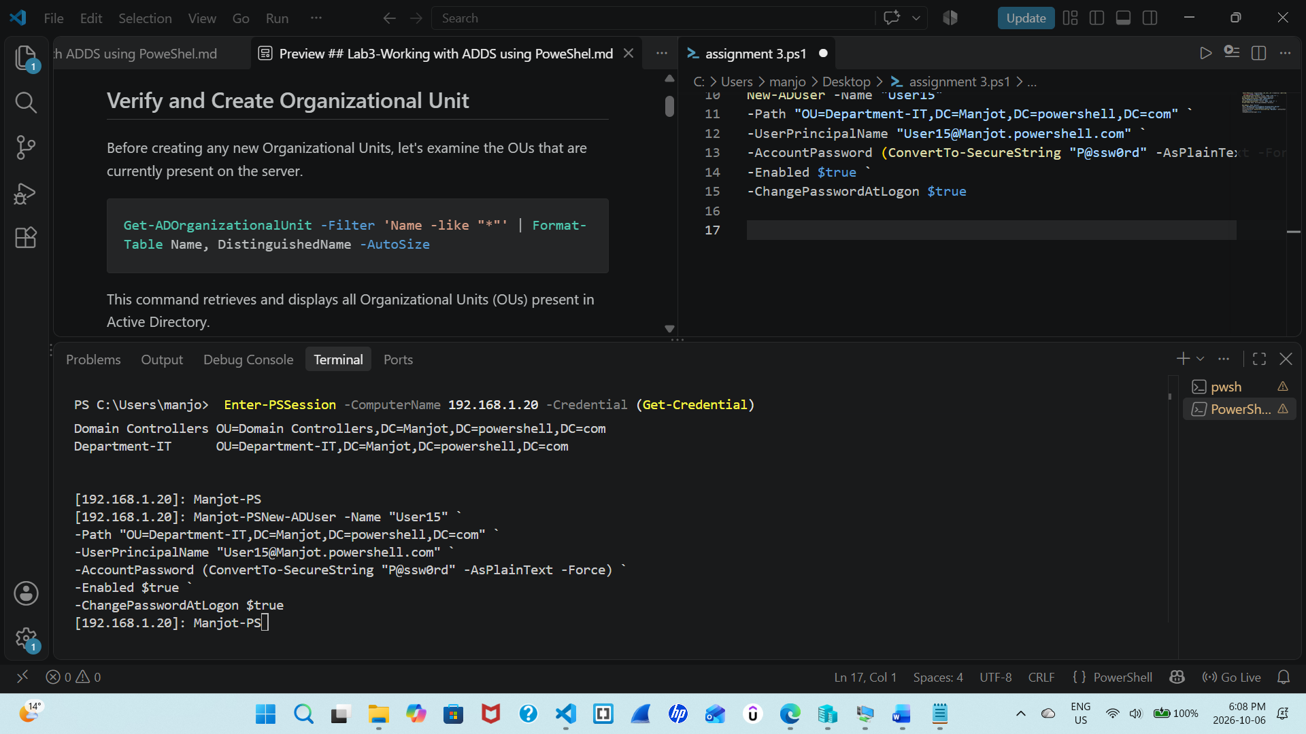
Paste the full screenshot here.
Step 5:verifying our previous command
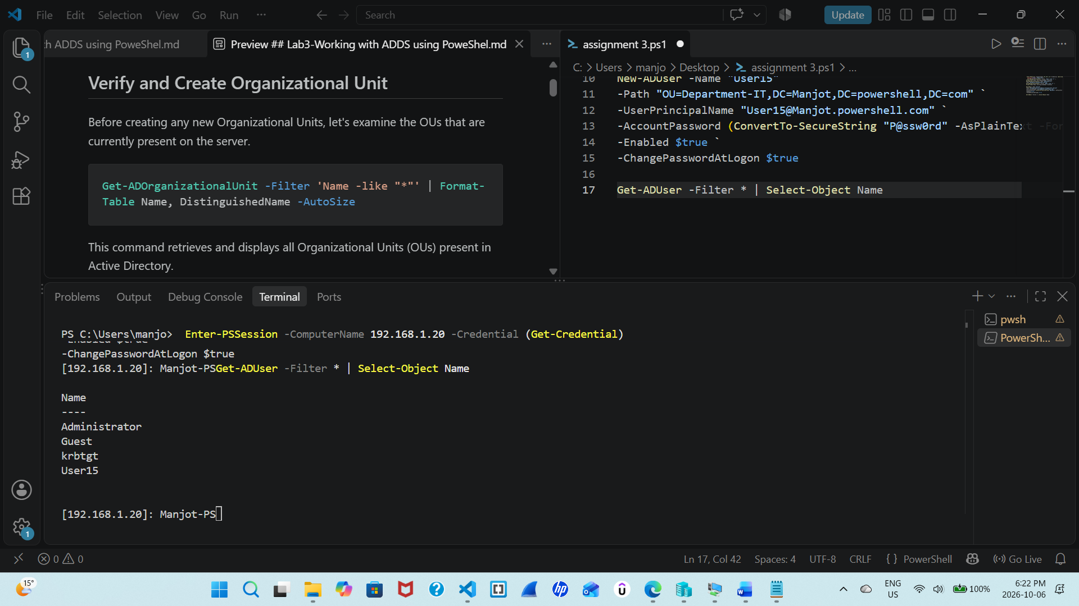
Here we can clearly see the user15 we created. (Paste the full screenshot here)
Step 6: Here we are copping our csv file from host computer to the server
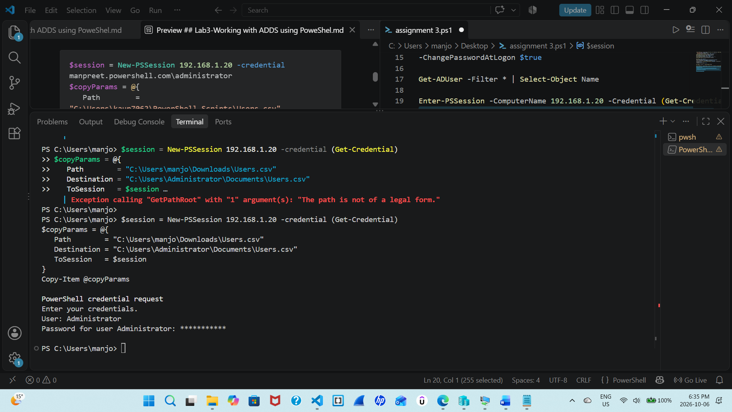
Paste the full screenshot here.
Step 7:wrintign the script
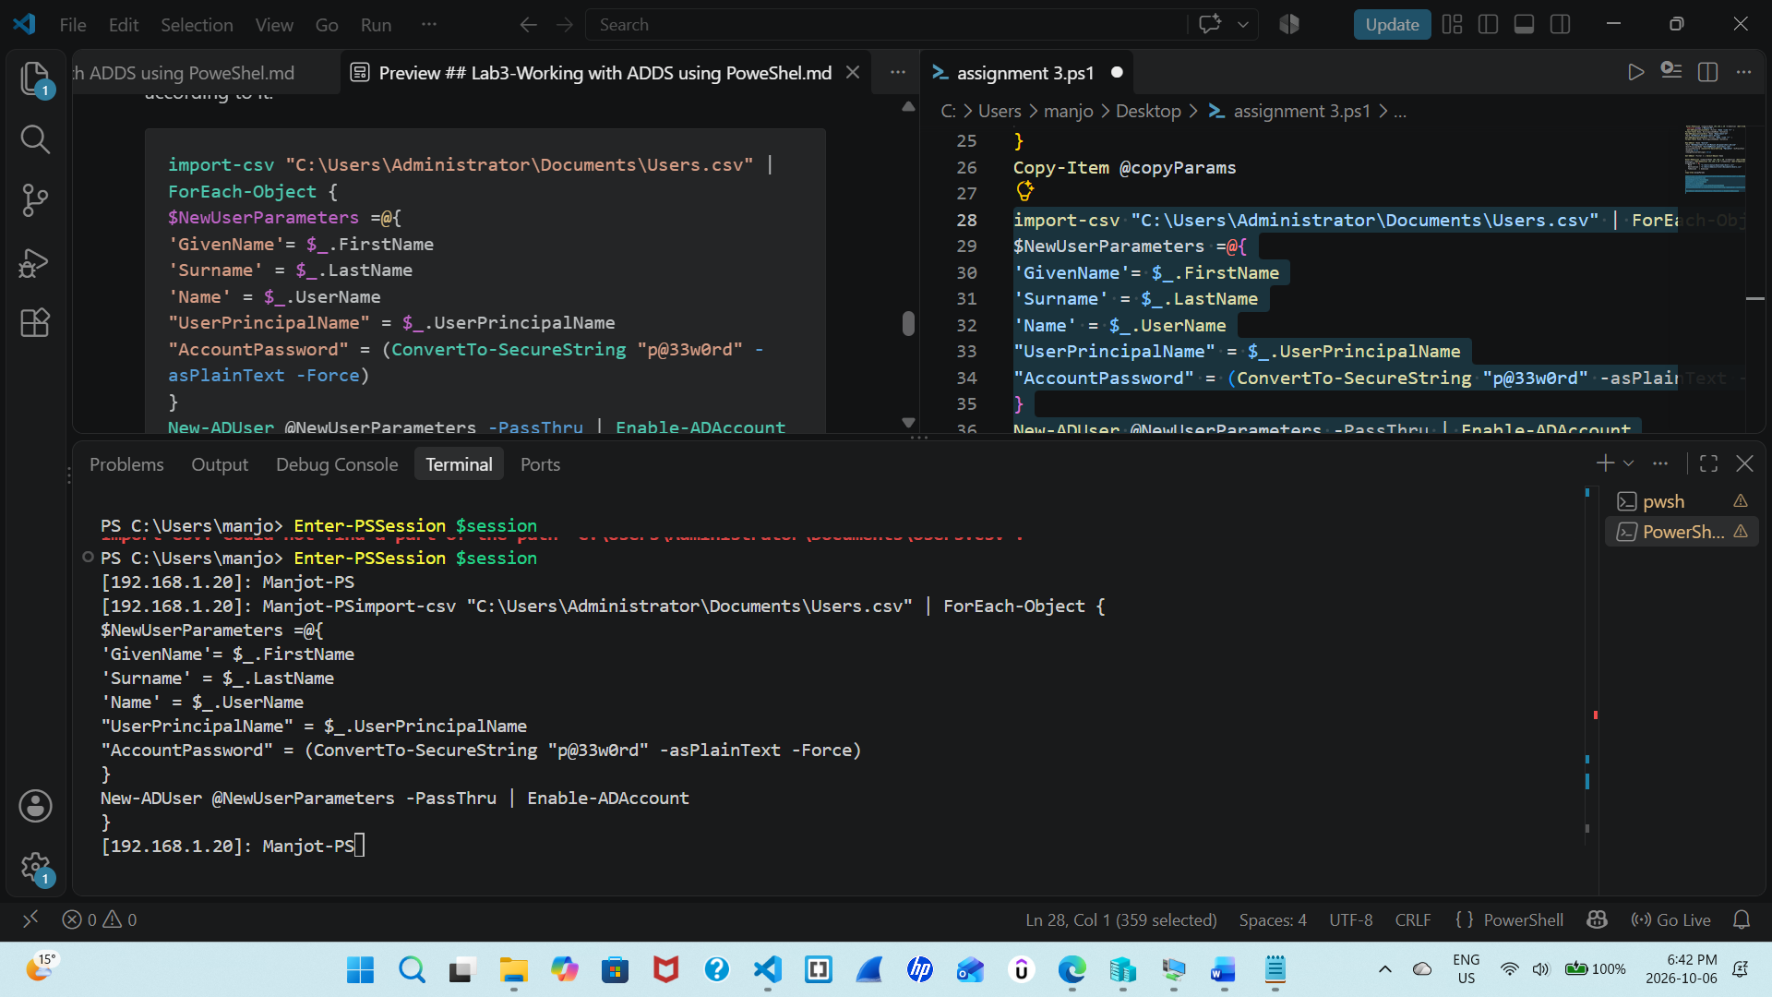

Paste the full screenshot here.
Step 8:we are verifying the users also we are doing this in server connected as we already copied the csv file there
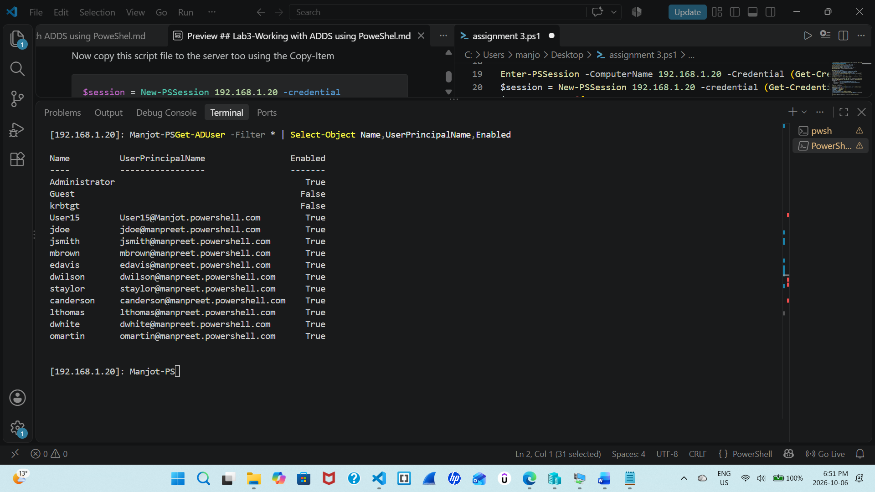
Paste the full screenshot here. Describe the purpose of the given script.
Step 9:verifying OUS
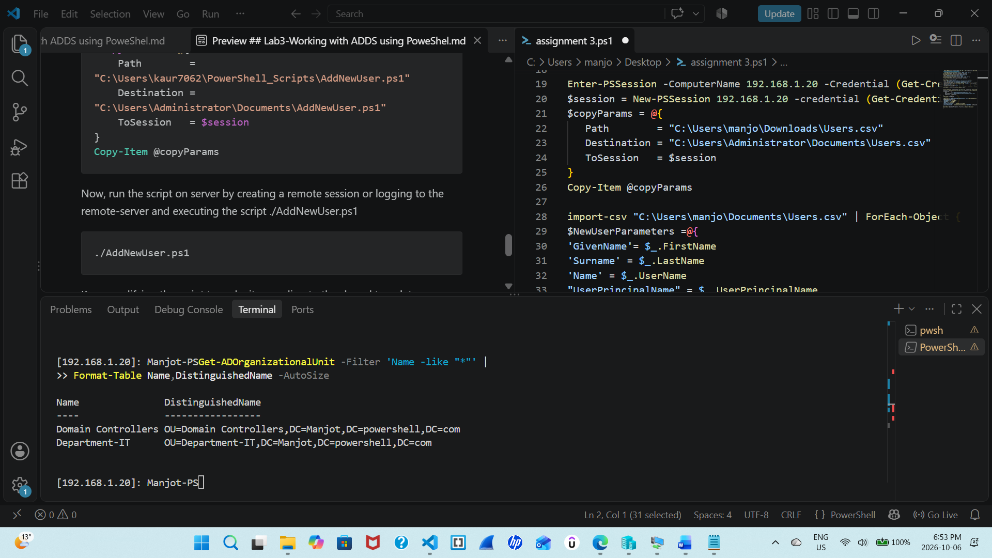
Paste the full screenshot here.

Step 10: checking the IT IS IN CORRECT DEPARTMENT so csv in in correct department
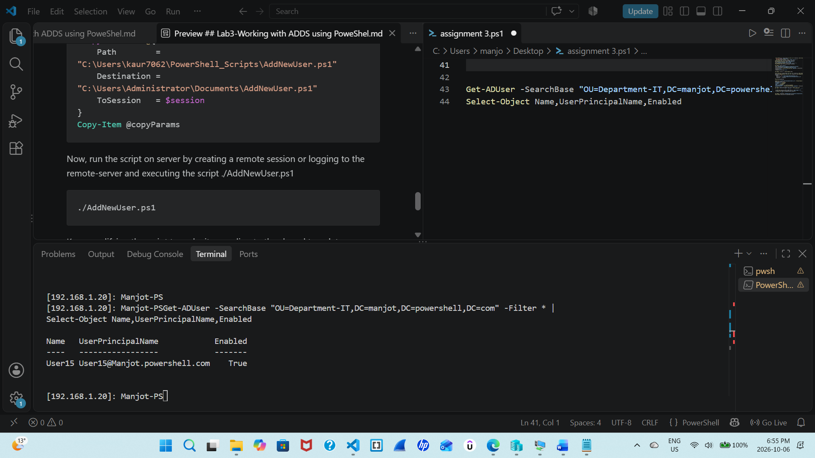

Paste the full screenshot here.
Step 11: verifying our final result

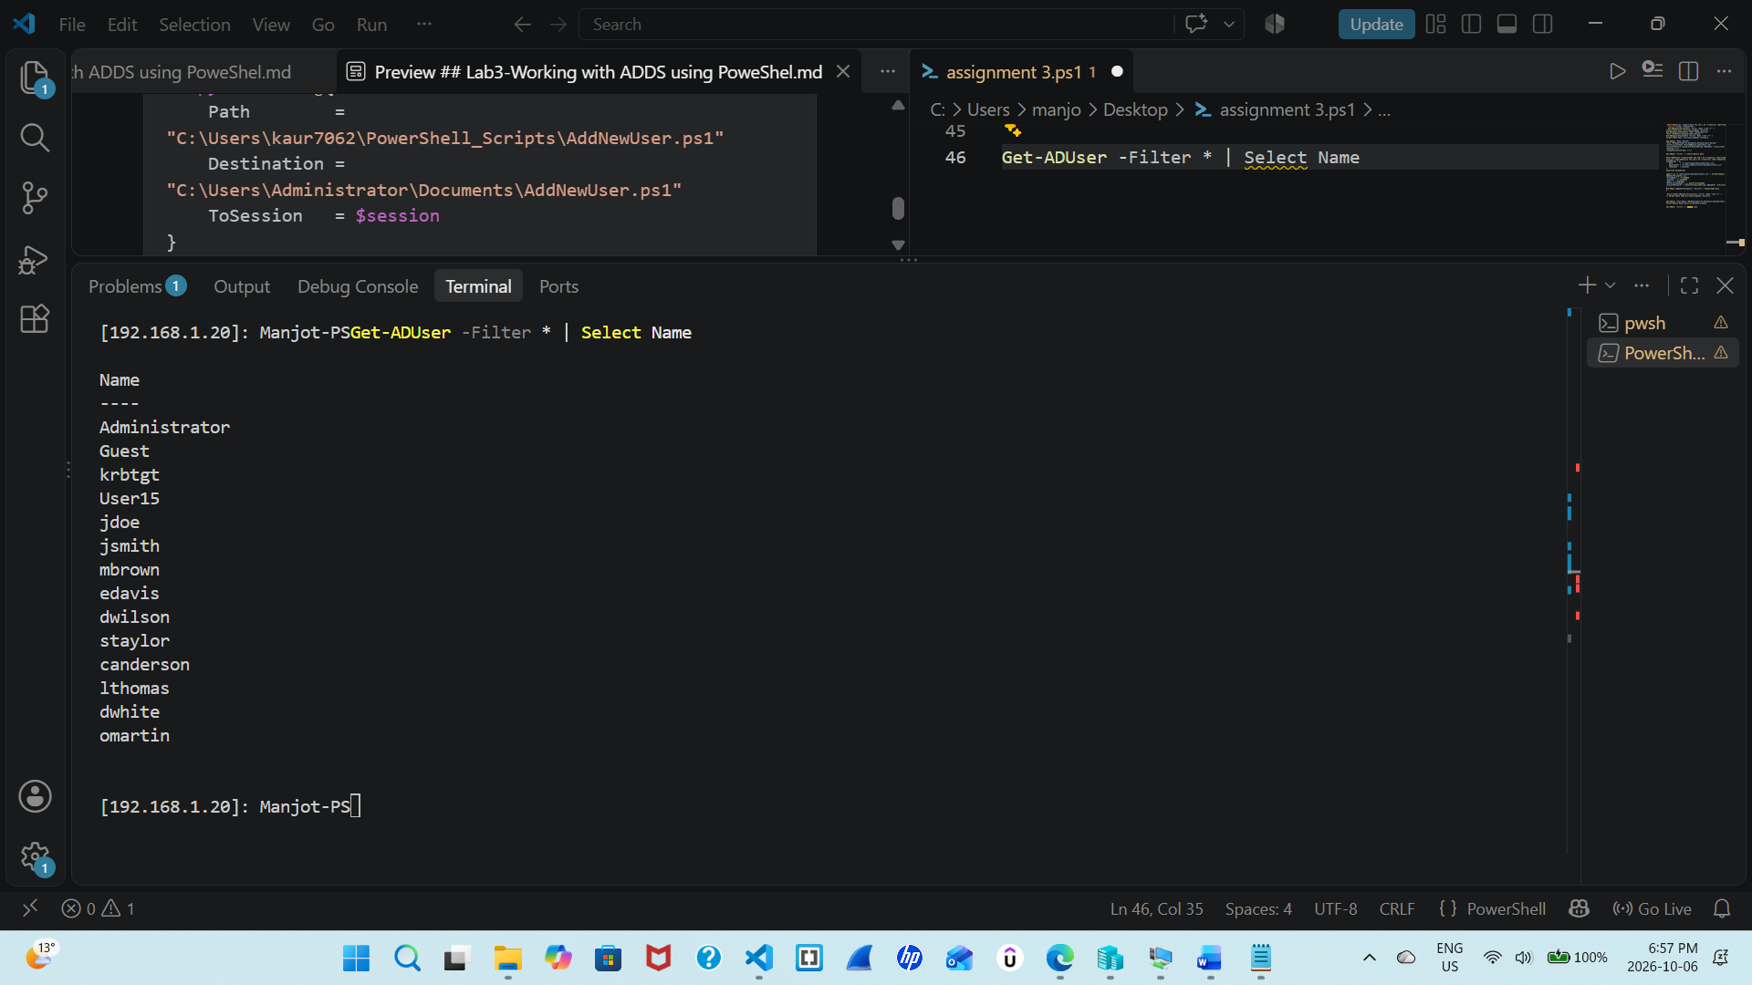

We didn’t create the script in notepat but used VS code and connected to server direcrly via remote session and run the commands there and make a import from our host to server also of the csv file

Reflection:
Share your learning in a paragraph of 50-100 words. Share any challenges you faced and how you overcome them.
In this LAB I learned how to manage the Active directory using PowerShell. Importing csv form host to server, How to use csv to create users. Some errors do occurred while creating the path but was solved later by using correct path and execute commands on server instead of creating on host notepad and pasting them on server. Overall this lab helped me learning about active directory on server using remote session method.

GIT HUB
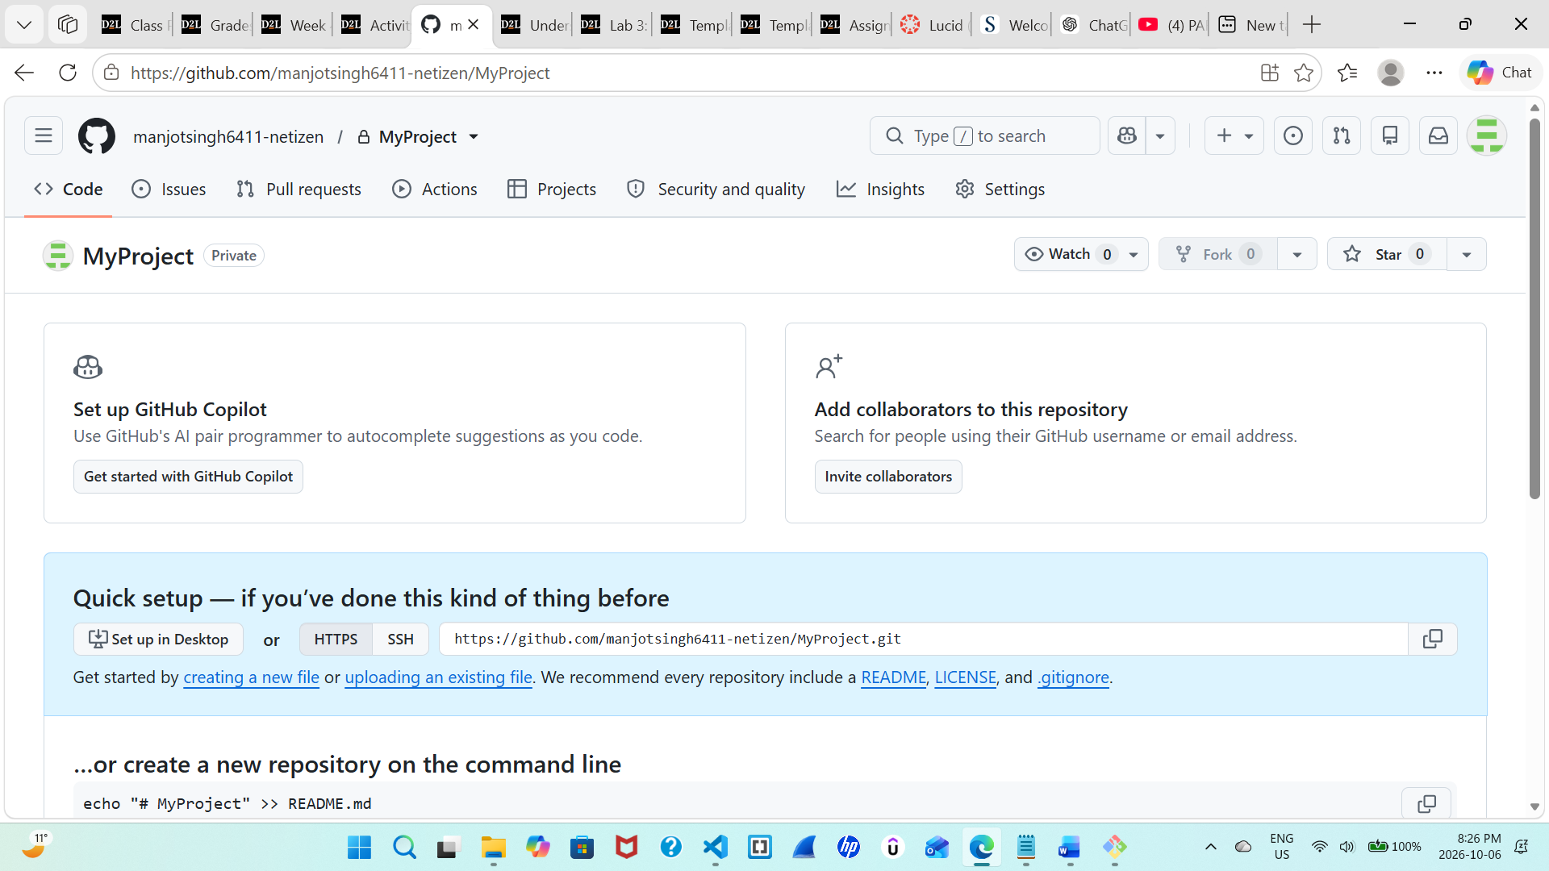

https://github.com/manjotsingh6411-netizen/MyProject.git

